1 Cygwin installation instructions
You can skip this step if you already have Cygwin installed on your machine. If you install SDE60601 and find problems with gdb's graphical interface, you may have a problem with the Cygwin version on your machine. Please go back to this step to reinstall cygwin.
SDE，MIPSsim were originally development tools under Linux. Cygwin should be installed on the Windows platform to simulate the Linux environment.

- Go to the Cygwin\ directory and double-click setup.exe
- Select "Install from Local Directory" as shown below.
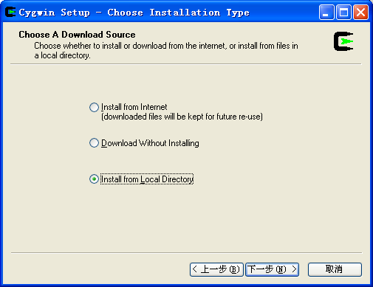

- Select the installation path and recommend D:\Cygwin\ or E:\Cygwin\
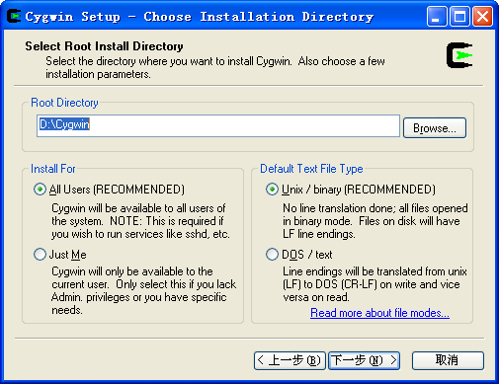

- Select the path to the resource files you need to install, which is the Cygwin directory
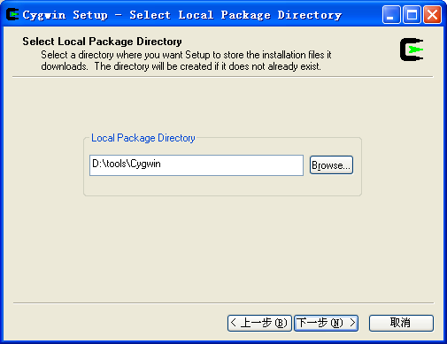

- Skip this step if it is a new installation.
If you already have Cygwin installed on your machine and want to reinstall Cygwin, select All →Uninstall, to uninstall all previous installations, and then click Next until you have finished and then continue to reinstall from step 1.
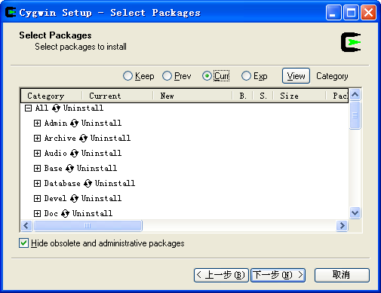

- Add the following tools for the selected installation:
NOTE：
1) When selecting the corresponding tool installation, the installation program will automatically check the associated installation package required by the tool
2) If you install the SDE toolchain before uninstalling the Cygwin toolchain, you need to run $sh. /bin/sdesetup.sh in the Cygwin environment to execute the setup script and reset the environment variable after reinstalling the Cygwin toolchain。

Please refer to the installation instructions of SDE6.6.1 below for details
Setup kit options selected：

- Select all as the Default option.
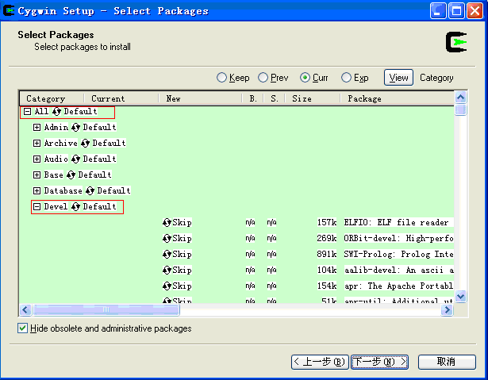

b) Click the "+" sign in front of the Devel package, expand the Devel category, and select Install
gcc : C compiler upgrade helper
gdb: The GNU Debugger
make : The GNU version of the 'make' utility
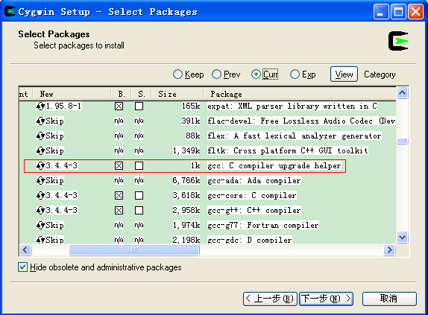
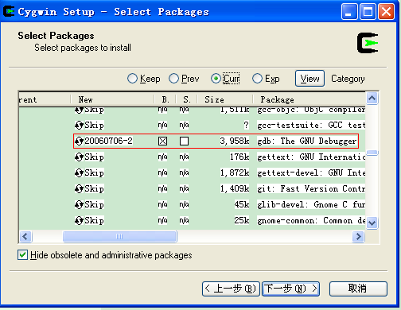
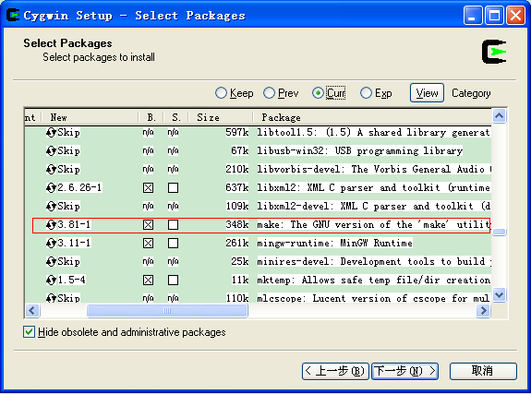

c) Click the "+" sign in front of the package Editors to expand the category Editors and select Install
ed : The GNU version of the original UNIX line editor
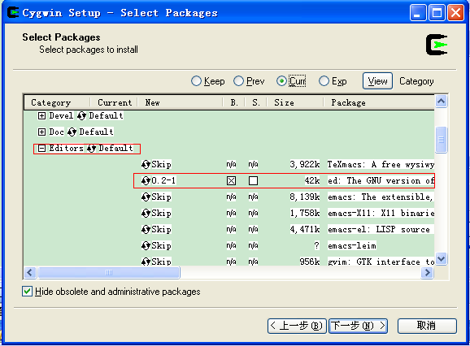

d) Click the "+" sign in front of the Perl package, expand the Perl category, and select Install
perl: Larry Wall's Practical Extracting and Report Language
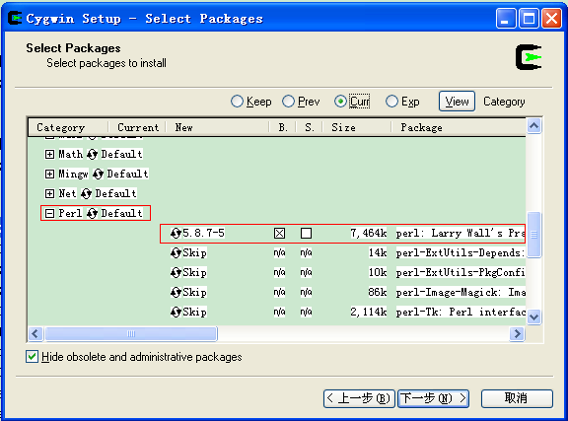

e) Click the "+" sign in front of the Python package, expand the Python category, and select Install
python: An interactive object-oriented scripting language
This option is recommended for internal developers to install (approximately 90 MB of space), and customers can choose not to install this option

- Go straight to the next step until the installation is complete.
- After the installation (without Python installed), the Cygwin folder was 168M in size and took up 276M in space

2 SDE6.6.1 Installation Instructions
Please copy sde60601\ pn00116-06.61-2b-mipssw-msde-v6.06.01. tgz to the tmp directory in advanc.
Open Cygwin and type in the command line:

$ cd /
$ cd tmp
$ cd /usr/local
$ mkdir sde60601
$ cd sde60601
$ gzip -dc /tmp/PN00116-06.61-2B-MIPSSW-MSDE-v6.06.01.tgz | tar xf –
$ sh ./bin/sdesetup.sh
Do you want to add a MIPSsim MDI library?
n
Do you want to create an FS2 probe configuration?
n
set environment globally in /etc/profile.d?
y

Turn Cygwin off and on again, and the SDE toolchain will be ready to use.

NOTE:
You can delete the compressed file pn00116-06.61-2B-mipssw-msde-v6.06.01. TGZ in the tmp directory after SDE6.6.1 installation complete.
After installation, the size of the SDE installation folder is 239MB and the space occupied is 267MB
The Cygwin folder (without Python installed) is 407M in size and takes up 543M in space.

